**Behavioural Design Pattern**

**State Pattern**

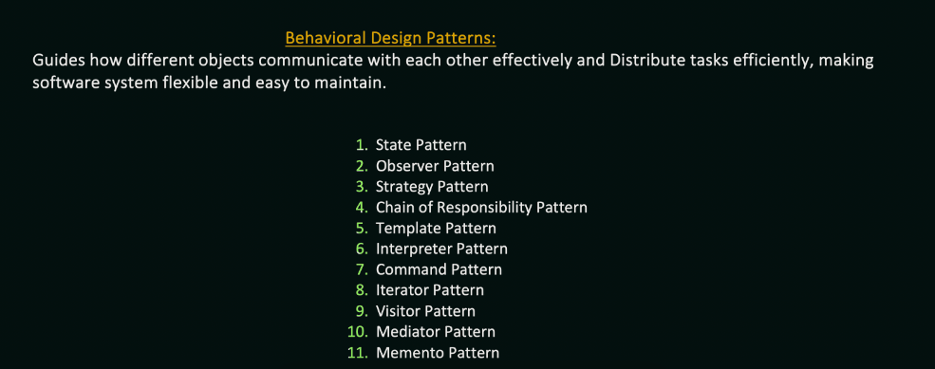

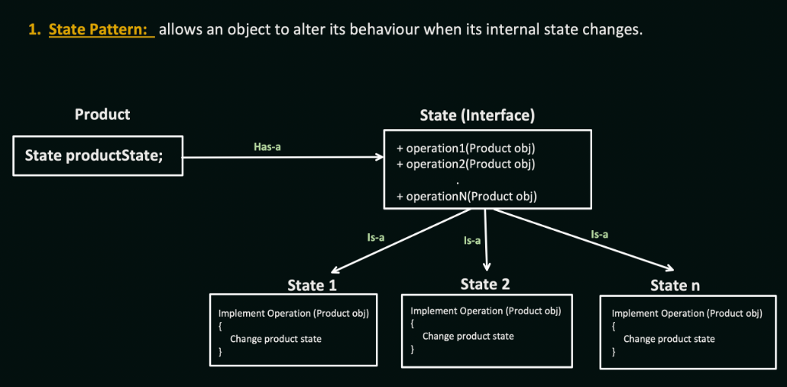

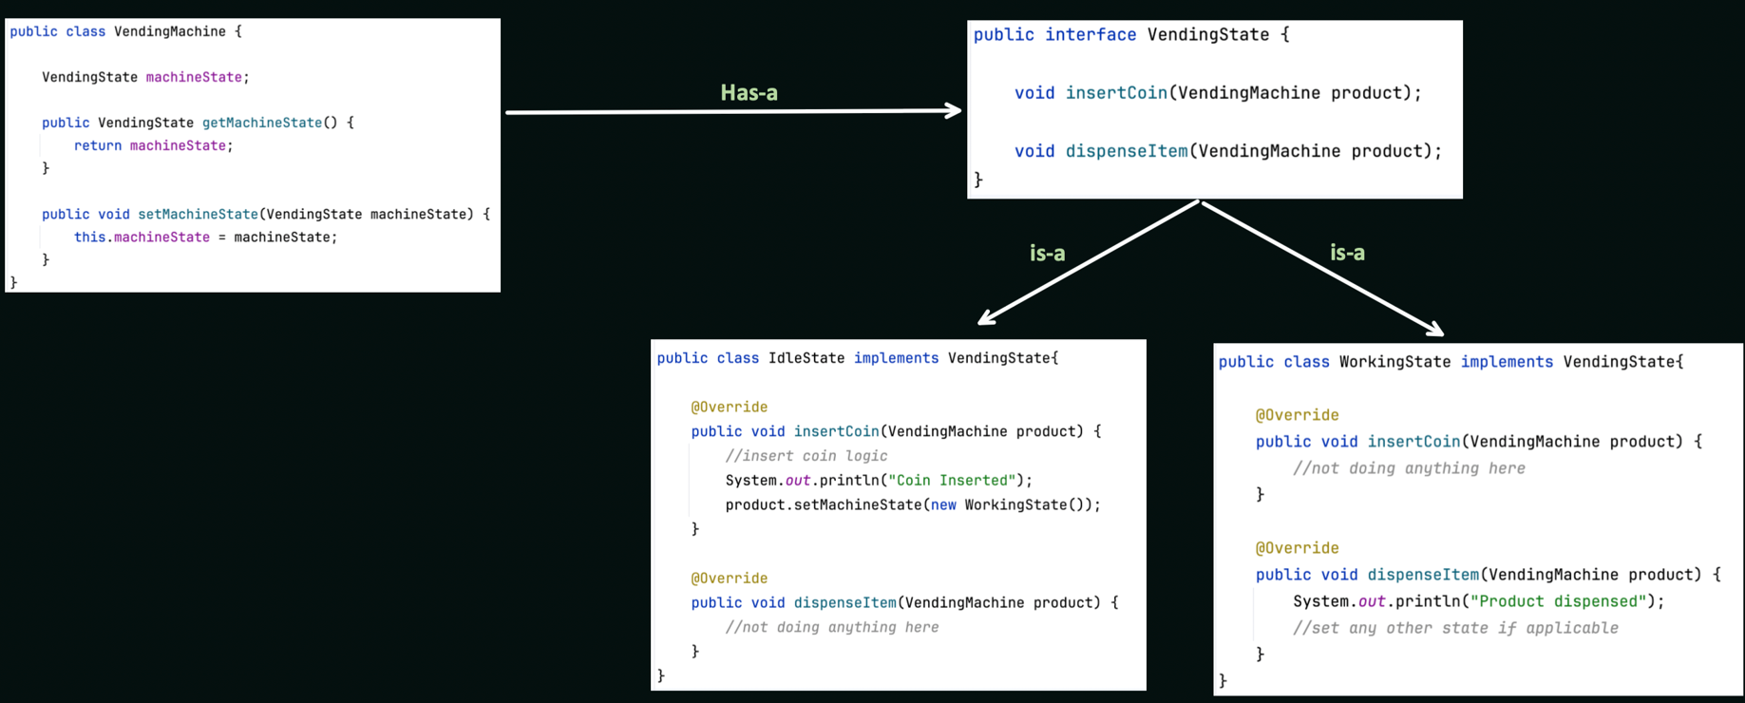

Observer Pattern  
  
  
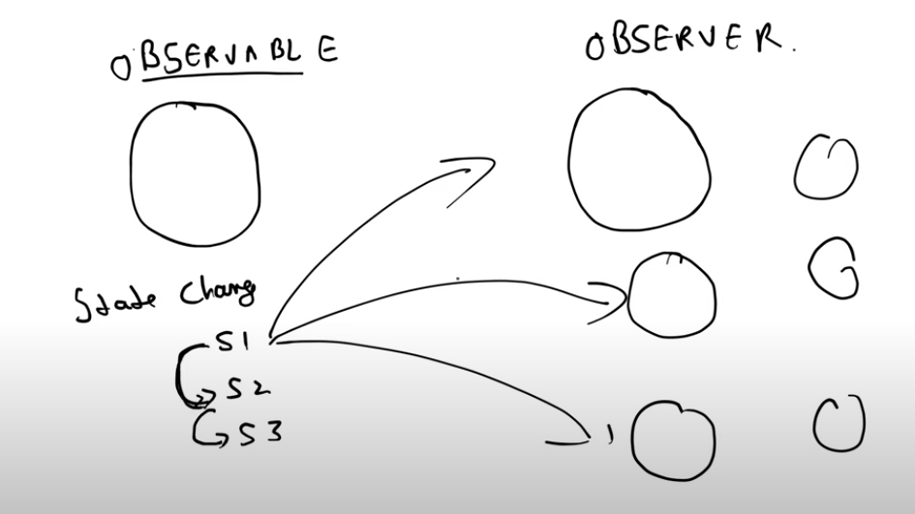  
  
Whenever my state. changes my observable will update the states to all the observors. One observable can be observed by many observors

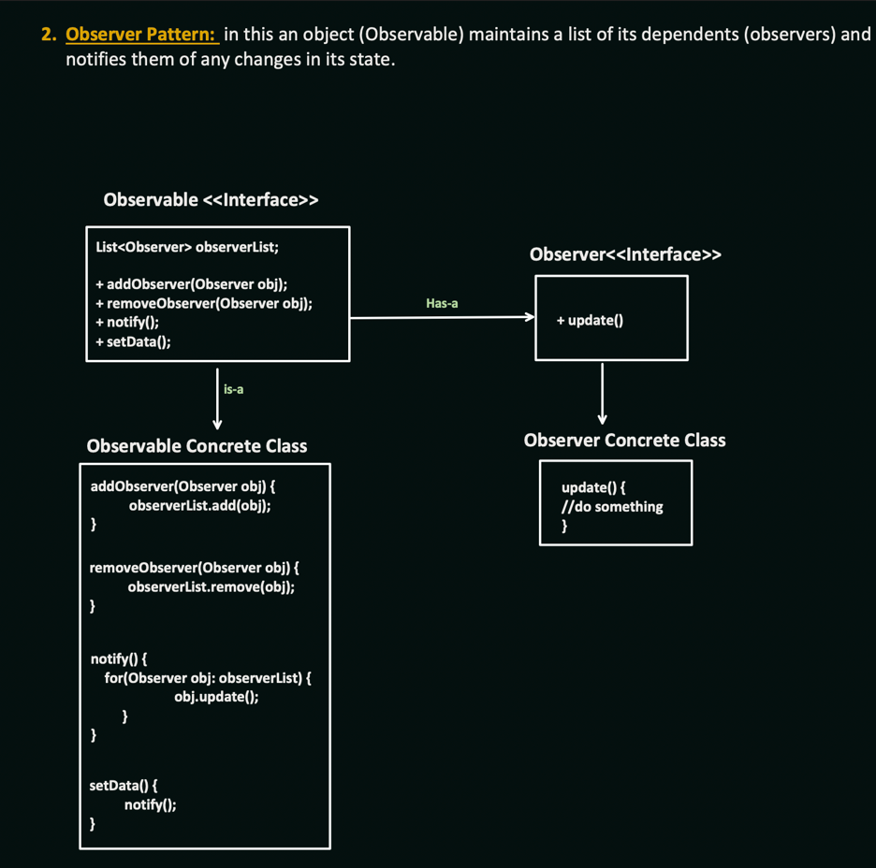

**Strategy Pattern**

We pass the strategy we want to use in the constructor of ShoppingCart.

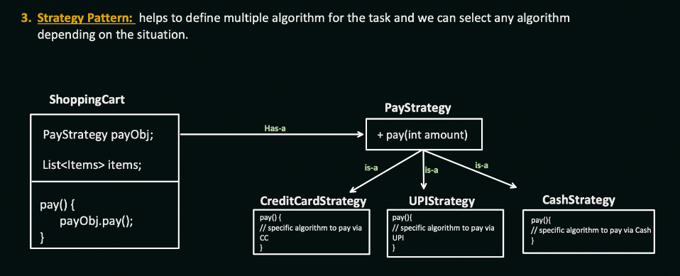

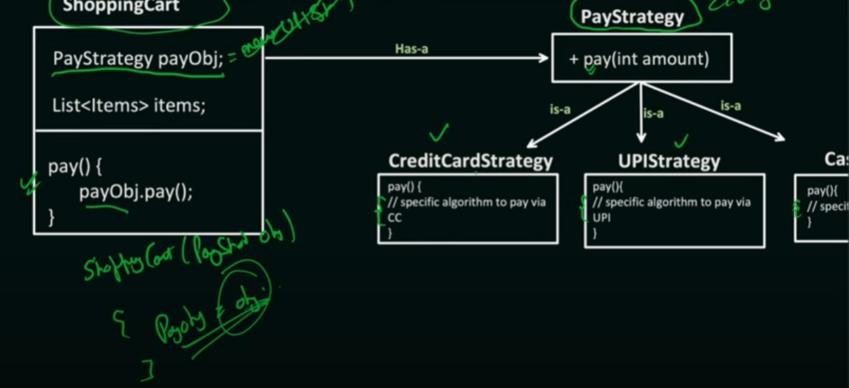

**Chain of Responsibility**

